**PRAKTIKUM 6**

**Image Sharpening**

**SISTEM PENGOLAHAN CITRA**

**PROGRAM STUDI SISTEM KOMPUTER**

**SCHOOL OF INFORMATION SCIENCE AND TECHNOLOGY**

**UNIVERSITAS PELITA HARAPAN**

**DISUSUN OLEH:**

**Alfa Satya Putra, B.Sc., M.Sc.**

**Part 1 – Gaussian Lowpass Filter**

Gaussian Lowpass Filter, as its name implies, is a lowpass filter in a form of Gaussian function as follows:



Where σ2 is variance, C is scaling constant to normalize sum of filter coefficients to 1, and filter is centered on the origin h(0,0).

For checking purposes, here’s a 7x7 Gaussian Filter coefficients where σ=0.84089642 (source: Wikipedia):

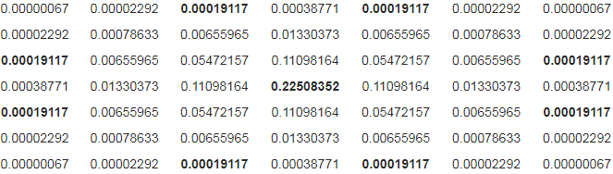

Tasks:

1. Write a Matlab/Octave function **h=gaussFilter(N,var)** that creates a NxN matrix with Gaussian Filter coefficients as its entries and with variance=var. Submit the m-file of this function along with the lab report.
2. Use said function to create a **7x7** Gaussian Filter with **σ=0.84089642**. Compare the result you get with the Wikipedia example (remember that center of the matrix corresponds to (0,0))
3. Compute the 32x32 DFT of the filter you made in part 2 using function **H = fftshift(fft2(h,32,32))**. fft2 is the 2D Fourier Transform, and fftshift is to center the (0,0) to the center of the image (both functions provided by Octave, you don’t need to create it).
4. Create a 32-element linearly spaced vectors from -π to π using the Octave function **linspace()**.
5. Plot the magnitude/spectrum of H obtained in part 3 as a 3D plot using **mesh(x,y,z)** command, where x and y are the x and y coordinates (for this part, we want x and y to be [-π, π] x [-π,π], use the linspace result from part 4 for x and y), and z is the 2D matrix of magnitudes (absolute of H from part 3). Save this plot and submit it along with the lab report.
6. Comment on the shape and values of the meshplot in 5 in the lab report. Does it agree with your expectation?

**Part 2 - Image Sharpening**

In this part, we will introduce a sharpening filter known as an **unsharp mask**. This type of filter subtracts the “unsharp” (low frequency) components of the image and produces image with sharper appearance. The unsharp mask is closely related to highpass filtering. Unsharp masking function of image f(i, j) is: 

Where h(i,j) is the lowpass filter, α and β positive constants so that α – β = 1. For the lowpass filter, use the Gaussian lowpass filter you made in Part 1.

Tasks:

1. Use the gaussFilter function you made in part 1 to create a 5x5 Gaussian Filter with var=1. Then use said filter to the **blur.tif** image using function **Y=filter2(h,X)** where X is original image, h is filter mask, and Y is filtered image (this function is provided by Octave, you don’t need to create it).
2. Write an unsharp masking function **b=unsharp(a)** using definition described above to **blur.tif,** with f(i,j) the original image, f(i,j)**h(i,j) result of part 1, **alpha = 5 and beta = 4.** Save resulting image.
3. Comment on the quality of the image result of the unsharp masking in the lab report.
4. Try changing coefficients of the unsharp function to **alpha = 10 and beta = 9.** Comment on the effect of changing coefficients in the lab report. Save the resulting image.
5. Hand in your m-files, and the filtered images for parts 2 and 4 along with the lab report.

References:

* <https://www.gnu.org/software/octave/>
* GNU Octave Manual
* Class Materials, Slide Week 5 & 6
* Purdue ECE 438 Lab 10a: <https://engineering.purdue.edu/VISE/ee438L/lab10/pdf/lab10a.pdf>